Bruce Grey Elementary Unit
Individual PD Evaluation FORM

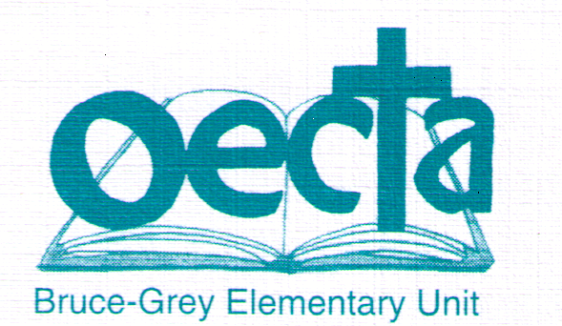

Please complete this form and send it along with a copy of the workshop or PD (conference) registration receipt to the Unit President. The Unit Treasurer will then issue you a cheque. Please indicate who the cheque should be made out to.

Cheque Issued to: ______________________________________________________

Member: _____________________________________________________________

School/Site: ___________________________________________________________

Workshop or Conference Name ___________________________________________________

Workshop or Individual PD Conference Dates(s): ______________________________________

Location: _____________________________________________________________

Please provide a brief description of the workshop or PD session or conference and whether you would recommend that other members attend this workshop or conference.

___________________________________________________________________________

___________________________________________________________________________

___________________________________________________________________________

___________________________________________________________________________

___________________________________________________________________________

___________________________________________________________________________

___________________________________________________________________________

___________________________________________________________________________

___________________________________________________________________________

___________________________________________________________________________

___________________________________________________________________________

___________________________________________________________________________

