Spirit of Education Request Form
Bruce Grey Elementary Unit
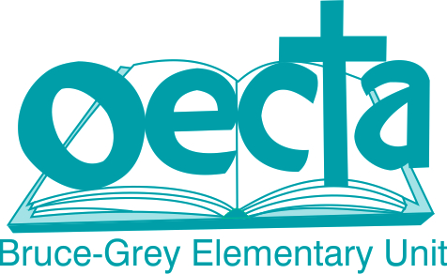

Spirit of Education
The Bruce Grey Elementary Unit provides money annually to support Spirit of Education activities in our elementary schools. The funds received may be used to support or sponsor an event or activity that your school is conducting. Typically, the money is accessed to support a community event during Education Week, but the request is not limited to that week. Please fill in the form below and submit to the Unit Treasurer to receive your school’s designated funds. Please ensure your school acknowledges this donation with a poster or announcement in the newsletter to parents.

Notre Dame, Kincardine and St. Basil’s - $250
Mildmay, Formosa, Port Elgin, Hanover, Walkerton, Durham, Teeswater, Chepstow - $200

Application Date: ______________________________________________

Name: __________________________________________________________

School: _________________________________________________________

Cheque Payable to: ____________________________________________

Event or Activity to be Sponsored:

____________________________________________________________________________________________________________________________

____________________________________________________________________________________________________________________________

____________________________________________________________________________________________________________________________

____________________________________________________________________________________________________________________________
Reviewed Sept 2022

